Grove - Gas Sensor(MQ5)

(Redirected from [Twig - Gas Sensor(MQ5)](http://seeedstudio.com/wiki/index.php?title=Twig_-_Gas_Sensor(MQ5)&redirect=no))

|  |
| --- |
| **Contents**   [[hide](javascript:toggleToc())]   * [1 Introduction](http://seeedstudio.com/wiki/Twig_-_Gas_Sensor(MQ5)#Introduction) * [2 Features](http://seeedstudio.com/wiki/Twig_-_Gas_Sensor(MQ5)#Features) * [3 Application Ideas](http://seeedstudio.com/wiki/Twig_-_Gas_Sensor(MQ5)#Application_Ideas) * [4 Specification](http://seeedstudio.com/wiki/Twig_-_Gas_Sensor(MQ5)#Specification) * [5 Usage](http://seeedstudio.com/wiki/Twig_-_Gas_Sensor(MQ5)#Usage)   + [5.1 Hardware Installation](http://seeedstudio.com/wiki/Twig_-_Gas_Sensor(MQ5)#Hardware_Installation)   + [5.2 Programming](http://seeedstudio.com/wiki/Twig_-_Gas_Sensor(MQ5)#Programming) * [6 Support](http://seeedstudio.com/wiki/Twig_-_Gas_Sensor(MQ5)#Support) * [7 Version Tracker](http://seeedstudio.com/wiki/Twig_-_Gas_Sensor(MQ5)#Version_Tracker) * [8 How to buy](http://seeedstudio.com/wiki/Twig_-_Gas_Sensor(MQ5)#How_to_buy) * [9 See Also](http://seeedstudio.com/wiki/Twig_-_Gas_Sensor(MQ5)#See_Also) * [10 Licensing](http://seeedstudio.com/wiki/Twig_-_Gas_Sensor(MQ5)#Licensing) |

Introduction

The Grove - Gas Sensor(MQ5) module is useful for gas leakage detection (in home and industry). It can detect LPG, natural gas, town gas and so on. Because it has a fast response time once it has pre-heated, measurements are almost instantaneous. Note that the sensitivity can be adjusted by the potentiometer.

**Model: [the-link-on-Bazaar Model-number]**

[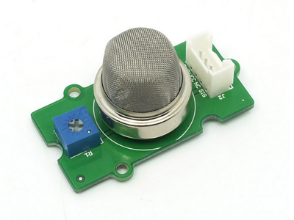](http://seeedstudio.com/wiki/File:Twig-Gas_Sensor.bmp)

Features

* High sensitivity to LPG, natural gas, town gas
* Low sensitivity to alcohol and smoke
* Fast response
* Stable and long life

Application Ideas

* Gas leakage detection
* Toys

Specification

|  |  |  |  |  |  |
| --- | --- | --- | --- | --- | --- |
| **Items** | **Parameter name** | **Min** | **Type** | **Max** | **Unit** |
| VCC | Working Voltage | 4.9 | 5 | 5.1 | V |
| PH | Heating consumption | 0.5 | - | 800 | mW |
| RL | Load resistance |  | can adjust |  |  |
| RH | Heater resistance | - | 31 | - | Ω |
| Rs | Sensing Resistance | 3 | - | 30 | kΩ |

Usage

**Hardware Installation**

Connect this module to the analog pin of Grove Base Shield. You can detect the voltage from the sensor through the SIG pin. The higher the concentration of the gas, the higher the output voltage on the SIG pin. Sensitivity can also be regulated by rotating the potentiometer. Please note the best preheat time of the sensor is about 24 hours. For the detailed information about the MQ-5 sensor please refer to the datasheet.

Please note that the MQ5 sensor is rated to draw (less than) 800 mW @ 5v (160mA) for the sensor heating module. When powering the sensor off your MCU, make sure that your voltage regulator has enough capacity to handle the MQ5 in addition to its other responsibilities.

[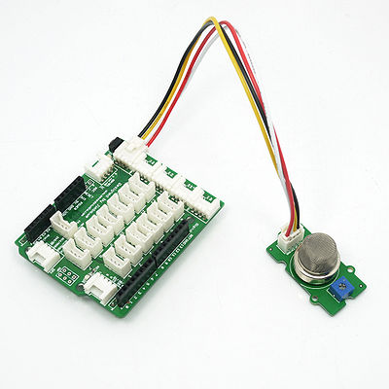](http://seeedstudio.com/wiki/File:Grove-Gas_sensor.jpg)

**Programming**

Connect the module with Grove Base Shield using A0 like the picture above. Use the program below to gain the voltage. You can see the voltage will go higher as the concentration of the gas increments.

**void** **setup**() {

**Serial**.begin(9600);

}

**void** **loop**() {

**float** vol;

**int** sensorValue = analogRead(A0);

vol=(**float**)sensorValue/1024*5.0;

**Serial**.println(vol,1);

}

Support

[Ask questions on Seeed forum](http://www.seeedstudio.com/forum).

Version Tracker

|  |  |  |
| --- | --- | --- |
| **Revision** | **Descriptions** | **Release** |
| v0.9b | Initial public release | 16,Aug,2011 |

* [File:Twig - Gas Sensor eagle files.zip](http://seeedstudio.com/wiki/File:Twig_-_Gas_Sensor_eagle_files.zip)
* [File:Gas.pdf](http://seeedstudio.com/wiki/File:Gas.pdf)
* Demo code
* [File:MQ-5.pdf](http://seeedstudio.com/wiki/File:MQ-5.pdf)